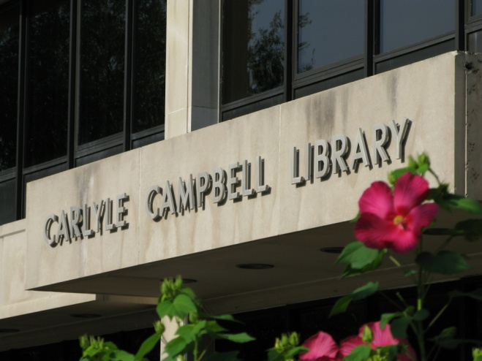

Welcome to Meredith College

and the Carlyle

Campbell Library

CCL is here to help you with your classes this summer.

There are over 300,000 books, 8,000 videos, 9,000 musical scores, and thousands of magazines and journals available for your research

Cameras, projectors, DVD/Video players, CD boomboxes and more equipment are available for your use in the library. Work with a Governor’s school faculty member if you need to take the equipment out of the library.

Library staff will be glad to help you find and use what you need. Call the Information Desk (919-760-8095), the Media Services Desk (919-760-8444), or the Circulation Desk (919-760-8532) for assistance.

The Library website is a good source of information about the library as well as a connection to many research resources:

http://www.meredith.edu/library

You may use your Governor’s School ID to check out library books and musical scores for up to two weeks. Be sure to return them on time to avoid fines!

There are photocopier/scanners available in the library. Copies cost ten cents per page. Scanning and emailing document images to yourself is free.

You may use computers on the main floor of the library for library research.

Library Hours are:

Monday – Thursday 8:00am-9:00pm

Friday 8:00am-5:00pm

Saturday Closed

Sunday 1:00pm-9:00pm

Media Services Hours are:

Monday – Friday 8:00am-5:00pm

Saturday/Sunday Closed

Information Services are available:

Monday/Tuesday 9:00am-5:00pm, 6:00pm-9:00pm

Wednesday – Friday 9:00am-5:00pm

Saturday/Sunday Closed

Here are the rules that govern your use of the library.

I. How to get help
The three service desks on the main floor are the starting point for getting help. The library staff is available to help patrons use the library effectively. Services include:

- assistance in locating materials and information,
- help with designing research strategies, and
- instruction in the use of library resources.

Staff are on duty many hours the library is open; however, you may call Information Services (760-8095) or Media Services (760-8444) to make an appointment to get help at a specific time. You may also chat online with a reference librarian (see the library website).

II. Check out policies
A valid Meredith ID card must be presented to check out materials, including reserve items. Materials must be renewed in the library.

Most library materials are loaned for a two-week period and may be renewed twice provided they are not needed by another patron or the final due date has not been reached. Video tapes, laser discs, and DVDs circulate for 3 hours within the library only. DVDs-to-go, however, may circulate outside the building for 3 days.

The library reserves the right to restrict the circulation of high demand items. The library also reserves the right to refuse borrowing and building use privileges to any individual who violates the regulations of the library or Meredith College.

Reference books, periodicals, and videotapes do not circulate out of the library building.
<div align="center">

IV. Reserve materials
Reserve materials may be checked out from the circulation desk. Faculty specifies one of the following types of reserve for each item:

- STRICT — 3 hours in-library use only (check-out limit: 4 items)
- OVERNIGHT — checked out overnight and due 1 1/2 hours after the library opens the next day (check-out limit: 2 items)
- THREE-DAY — to be returned within a 3-day period (check-out limit: 2 items)

Reserve check outs are on a first-come, first-served basis and cannot be placed on hold.

V. Overdue fines
Students are responsible for the payment of fines for overdue items, including reserve materials, and for replacement costs of lost items. The fine is 10 cents per day for most items, 50 cents per hour for 3 hour reserve materials (charged for each hour the library is open), $3.00 per day for 3 day reserves, and $1.00 per day per item for circulating audio-visual items. Borrowing privileges are suspended for any student with outstanding fines and are reinstated when fines are paid.
<applet code="fphover.class" codebase="_fpclass/" width="120" height="24"><param name="text" value="FACULTY"><param name="color" value="#C0C0C0"><param name="hovercolor" value="#0000FF"><param name="textcolor" value="#FFFFFF"><param name="effect" value="glow"><param name="url" value="http://152.35.128.16/library/Facultypolicies.html#Faculty lost item charges" valuetype="ref"></applet>

VI. Outdoor book return
An outdoor book return is conveniently located in front of the Carlyle Campbell Library. All audio-visual and reserve materials MUST be returned inside the building, however, to prevent damage.

VII. Interlibrary loans
Due to time constraints, interlibrary loans will not be requested for Governor’s School students <big>.
</big><applet code="fphover.class" codebase="_fpclass/" width="120" height="24"><param name="text" value="FACULTY"><param name="color" value="#C0C0C0"><param name="hovercolor" value="#0000FF"><param name="textcolor" value="#FFFFFF"><param name="effect" value="glow"><param name="url" value="http://152.35.128.16/library/Facultypolicies.html#Interlibrary loans for faculty" valuetype="ref"></applet>

VIII. Photocopier/Scanners
Photocopiers that accept cash are available on the main and ground floors. Copies cost 10 cents per page. Copiers also work as scanners. Scanning is free and you may email the resulting images to yourself.

Change may be obtained at the circulation desk for use in library machines.

Refunds for photocopies are made by the accounting office in Johnson Hall. Ask at the circulation desk for more information.

Microform reader/printers are available in the Creation Station.

IX. Using library computers
Library computers near the Information Services desk are available for Governors School faculty and students for research. Computers in the LINC Center are off limits for unsupervised Governors School students.

- Reserving the library study rooms
The library has two study rooms that can be reserved by Governor’s School students.

The Blue Group Study room (206) can accommodate 10 people. The Ground Floor Group Study room (025) can accommodate 8 people (seating only, no table). Reservations are self-serve—go to http://infotogo.meredith.edu/roomreservations to sign in and create a reservation. Other group study rooms in the library are reserved for Meredith students.

XI. Food, drink, and smoking
Food and drinks are allowed in the library. Smoking is not allowed in the library.
Please help us keep the library clean. Dispose of all trash in receptacles in your area. If there is a mess or a spill, please contact the staff so they can help you clean up.

XIII. Media Services AV equipment policy
AV equipment is an important part of the teaching/learning environment at Meredith. Technology for the classroom is an expensive resource. All users must use equipment properly and carefully, and must be mindful of equipment security while they are using such equipment.

XIII.A. Borrowing AV equipment from the AV pool in the library
Governor’s School students may borrow most pieces of circulating Media Services equipment from the AV pool for use in the library. For use of equipment outside the library, a Governor’s School faculty member must check out items for you.

The procedures for regular check-out of AV equipment are as follows:

- Equipment must be reserved in person at Media Services during regular Media Services summer hours.

- When reserving equipment, students must identify themselves as Governor's School students and should present a valid Meredith ID card. Media Services will retain the ID card while the equipment is in use in the library building. The reservation slip should include a local campus address and local campus phone number. If another individual will be picking up the equipment, or if another individual will be using the equipment, this should be noted on the reservation form.

- Media Services staff will create a reservation slip for the Governor’s School student user. The slip will indicate check out date and time and return time.

- At the designated time, equipment booked for the Governor’s School student will be set out at the Media Services counter for use during regular library hours.

- Borrowed equipment should be returned to the Media Services counter at the time stated on the reservation slip. At that time the student’s ID card will be returned.

- Governor’s School students are responsible for prompt return of all borrowed equipment and accessories. Media Services does not provide delivery or pick up service.

- Borrowers and/or the Governor's School are responsible for any loss or damage of equipment while in a Governor’s School student user's possession, normal wear and tear excepted.

- Persons borrowing equipment are responsible for it. Users should never leave AV equipment unattended, should never allow untrained users to use AV equipment, and should never attempt to alter the normal functioning of any piece of AV equipment.

- All use of Meredith College's AV equipment must be in strict compliance with current copyright laws. This includes public performances of films and videos. Ensuring the Governors School's compliance with copyright laws is, of necessity, the sole responsibility of Governor's School staff. Students who have copyright-related questions are encouraged to consult with Governor’s School faculty.

- Failure to abide by the above stated policies for Governor’s School students will jeopardize a user's privilege of using Meredith audiovisual resources.

XIII.B. Using AV equipment assigned to classrooms, auditoriums, and other campus spaces

Many pieces of AV equipment are permanently assigned to classrooms, auditoriums, and other spaces on campus. Governor’s School students should respect these assignments and not move equipment from room to room with permission. All equipment should be used responsibly.

- Users and/or the Governor's School are responsible for reimbursing Meredith College for any loss or damage of any such audiovisual equipment while in a Governor’s School user's possession, normal wear and tear excepted.

- Users should never leave AV equipment unattended, should never allow untrained users to use AV equipment, and should never attempt to alter the normal functioning of any piece of AV equipment.

- For reasons of safety and economy, Governor’s School students are encouraged to make sure equipment is properly turned off when it is no longer being used. This is very important for all video and data projectors. Users of such projectors must learn the proper shutdown procedures, or they will risk losing the privilege of using these resources. Students should ask Governor’s School faculty if they are not familiar with shutdown procedures for these projectors.

- Governor’s School students are encouraged to help secure Meredith's audiovisual equipment by locking rooms that are not being used, whenever possible and appropriate.

- All use of Meredith College's AV equipment must be in strict compliance with current copyright laws. This includes public performances of films and videos. Ensuring the Governors School's compliance with copyright laws is, of necessity, the sole responsibility of Governor's School staff. Students who have copyright-related questions are encouraged to consult with Governor’s School faculty.

- Failure to abide by the above stated policies for Governor’s School equipment use will jeopardize a student's privilege of using Meredith audiovisual resources.

- Please report equipment problems promptly to Media Services in the main library (760-8444).

