Film Permission Form

Dear GSE Parent/Guardian:

The GSE faculty and staff may supplement their classes with carefully chosen film clips or films that impart new information, present specific views on issues, or serve as texts for class discussion. Films can influence the way we think, react, and view both our own and other cultures. Some of the films the GSE faculty has chosen to show, both in class and in out-of-class electives, are rated R. These films have been selected despite their R rating because of the relevance of their content.

A list of films that we may use as part of our curriculum this session has been provided for you at check-in, and is available on the GSE website (www.ncgse.org). Films are listed according to the Area I that will use them. Films used for Area II and III are required of the entire student body and will be discussed by all students in small group settings with Area II and III faculty. Some films are used in electives such as our Foreign Film Series. If you agree to allow your child to participate in viewing and discussing these films, please check all applicable statements and sign and date below. Students for whom we do not have parental permission to view required films will be given alternative academic assignments that touch on the same topic. Thank you for your consideration of this matter.

Sincerely,
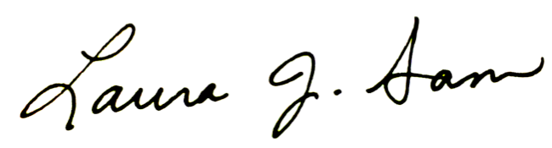

Laura Sam
Site Director – NC Governor’s School East

_____I give permission for my child to view any and all GSE films this session, including any added throughout the course of the session.

_____I give permission for my child to view all films except those listed on the opposite side of this sheet.

_____If there are any films added throughout the course of the session, please send a request for my consent to the email address below.

________________________________ ________________________________
Parent/Guardian Signature Parent E-mail address

________________________________ ________________________________ Date Parent Phone

Please DO NOT print and complete this permission form. You will be asked to do so at the registration table on Opening Day.

